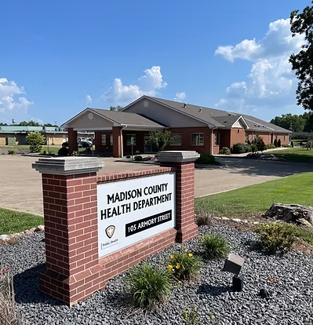



Community Health Assessment
2025 - 2029
  - Madison County Health Department
CHA


Table of Contents
Acronyms 3
Executive Summary 4
MAPP 2.0 Principles 5
MAPP 2.0 Phases 7
Community & Partner Engagement 8
Community Status Assessment 9
Process & Methods 9
Geographic Profile 9
County Demographics 10
Social Determinants of Health 11
Health Behaviors 11
Morbidity & Mortality 12
Healthcare Access 13
Youth Data 13
Additional Data 14
Community Context Assessment 15
CCA Summary 15
Process & Methods 16
Survey Demographics 16
Quality of Life 17
Healthcare 17
Physical & Mental Health 18
Health Education 19
Substance Use 19
Looking Forward 20
Community Partner Assessment 21
CPA Meeting Overview and health equity 21
Organizational Activities & the Essential Public Health Services (or SDOH) 22
Conversation Pieces 22
CPA Survey 22
CPA Reflection 25
CHA Next Steps 26
Sources 27

Acronyms
This section should spell out all acronyms used within the document. Here are a few to get you started:
[Insert health department initials]: [Insert health department name]
CDC: Centers for Disease Control and Prevention
CHA: Community Health Assessment
CHI: Community Health Improvement
CHR: County Health Rankings
MAPP: Mobilizing for Action through Planning and Partnerships
NACCHO: National Association of County and City Health Officials
SDOH: Social Determinants of Health

Executive Summary
The Madison County Health Department (MCHD) began this Community Health Assessment (CHA) process in August 2024, with our first community meeting hosted in October 2024. MCHD had robust support from community partners representing multiple sectors within Madison County. This CHA was completed with support from The Missouri Public Health Institute.
MCHD conducted a CHA to understand both the comprehensive health outcomes of Madison County residents and how residents perceive their health. Additionally, through this process, MCHD and our partners collaborated and reflected on the many ways we already work together and opportunities for future collaborations.
This CHA was conducted following the MAPP 2.0 process, which centers the following:
- Community Voice and Engagement
- Partnership and Collaboration
- Health Equity
- Systems-thinking
Data was compiled from the MAPP 2.0 assessments, namely the Community Status Assessment (CSA), Community Context Assessment (CCA), and Community Partner Assessment (CPA). Both qualitative and quantitative data were collected, which helped present a comprehensive image of health in Madison County. Throughout this process, similar themes were shared by partners and community members and were identified in health outcomes. These outcomes guided the development of health priorities that will be addressed in a future Community Health Improvement Plan (CHIP).
The CHA process presents an opportunity for many to better understand and address the health of Madison County. The CHA will be made accessible to all via the MCHD website, newsletter emails to community partners.
Additionally, all partners engaged in this effort received a printed, bound copy of the CHA. Printed, bound copies were also provided to schools and libraries in the county for broader public use.
Ultimately, the four priorities chosen by MCHD and partners were:
- Mental Health
- Substance Use Prevention
- Health Education
- Chronic Disease Awareness

MAPP 2.0 Principles
MAPP 2.0 is a framework for community improvement developed by the National Association of County and City Health Officials (NACCHO). MAPP stands for Mobilizing for Action through Planning and Partnership and was developed by NACCHO to provide communities with an up-to-date, community-driven, evidence-based, comprehensive strategic plan for identifying health priorities and developing strategies to address those priorities.
The following principles are the foundational principles of MAPP 2.0 and define the values which are interwoven into the MAPP framework:
Equity: Encourages shared exploration of the social injustices, including white supremacy, structural racism, class oppression, and gender oppression, that create and maintain inequities. Mobilizes community action to address these injustices through transformative changes to the structures and systems that maintain inequities and creates the opportunity for all to achieve optimal health.
Inclusion: Fosters belonging and prevents “othering” by identifying and removing barriers to community participation and ensuring all stakeholders and community members, regardless of background or experience, can contribute to MAPP.
Trusted Relationships: Builds connection and trust by honoring the knowledge, expertise, and voice of community members and stakeholders.
Community Power: Builds community power to ensure those most impacted by the inequities and actions addressed through CHI are those that guide the process, make important decisions, and help drive action.
Strategic Collaboration & Alignment: Creates a community-wide strategy that appropriately aligns the missions, goals, resources, and reach of cross-sectoral partners to improve community health and address inequities.
Data & Community Informed Action: Identifies priorities, strategies, and action plans that are driven by the community’s voice and grounded in community need as identified through timely qualitative and quantitative data.
Full Spectrum Actions: Encourages community improvement through approaches ranging from provision of direct services to policy, systems, and environmental change and community power-building for supportive communities that enable health and well-being for all.
Flexibility: Meets the real-time, evolving, and unique needs of diverse MAPP communities, organizations, and sectors through an adaptable framework.
Continuous: Maintains continuous learning and improvement through iterative community assessment, planning, action, and evaluation cycles.

MAPP 2.0 Phases
MAPP 2.0 consists of the following three phases, intended to be observed sequentially and in a continuous cycle:
Phase 1: Build the Community Health Improvement (CHI) Foundation
Phase 2: Tell the Community Story
Phase 3: Continuously Improve the Community
Phase 1 focuses on building a system for community partner collaboration. First, stakeholders are identified and their influence on CHI activities is analyzed. Next, the CHI infrastructure, partnerships, and leadership are established. Finally, a community vision is developed, and a starting point assessment is conducted to review past CHI processes.
Phase 2 involves gathering and analyzing data about the community and its health. In this phase, several assessments are developed and distributed to collect information from community members and stakeholders. Then, the themes found in the data will be used to identify key health issues, which will be shared with the community.
In Phase 3, the key health issues discovered in Phase 2 will prompt the creation of health priorities that will power the CHIP. Assigned subcommittees including stakeholders will construct goals and strategies for addressing each health issue. A system for monitoring and evaluating the CHIP will be established.
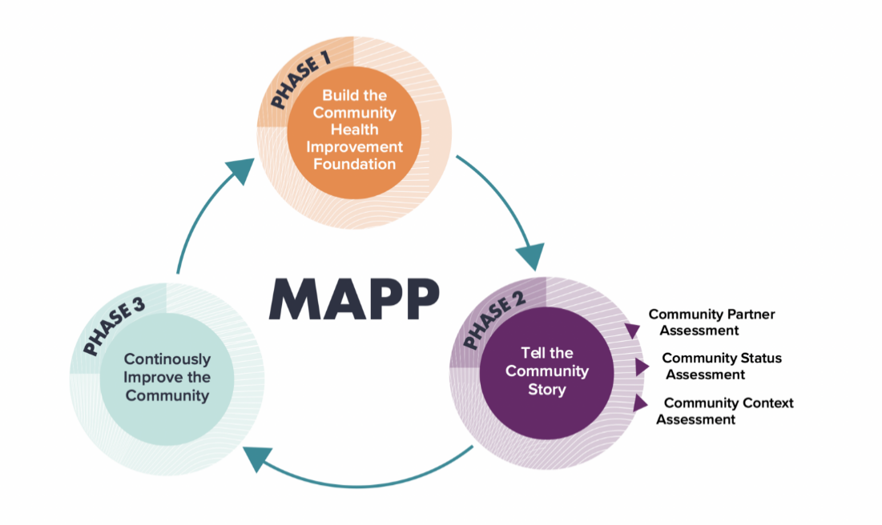

Community & Partner Engagement
Community partner engagement was vital to the CHA process as MCHD sought to gather accurate, relevant data to paint a comprehensive picture of the health of Madison County. Over the course of several months, community partners and MCHD staff met to review and provide feedback on CSA and CHA data, supply qualitative data regarding the community’s strengths and assets, built environment, and external influencers, and offer resources to support CHI efforts.
The following list is comprised of groups who, as community partners, contributed to the CHA process:
- EMAA- Outreach
- Caring Council
- Salvation Army
- MU Extension
- Madison Medical Center
- Gibson Center for Behavioral Change
- Fredericktown R-1 Schools
- Missouri Childhood Community Leader
- Parkland Pharmacy
- Madison County Emergency Management
- Matthew 7:12 Ministry
- Cherokee Pass Fire Department
- Madison County Sheriff
- Southeast Prevention Resource center
- Farmers
- Restaurant Owners

MCHD expresses gratitude to all who engaged in the CHA process. Partners provided invaluable insights that uniquely shaped the development of the CHA and will directly lead to a more impactful health improvement plan for Madison County.

Community Status Assessment

Process & Methods
The Community Status Assessment (CSA) for Madison County gathers and analyzes quantitative data to provide a better understanding of the community’s health, demographics, and health inequalities. Using the MAPP 2.0 framework, it collects information that helps tell the community’s story. Rather than simply examining health issues and behaviors, the CSA also delves into the influence of the Social Determinants of Health (SDOH) on health disparities (i.e. preventable differences in the burden of disease, injury, violence, or opportunities to achieve optimal health that are experienced by socially disadvantaged populations). This effort relies heavily on input from the community itself to ensure the findings accurately reflect Madison County’s reality. Quantitative data for the CSA was collected from secondary data sources.
For the collection of necessary information, data was taken from reputable sources such as Policy Map, the U.S. Census Bureau American Community Survey, and County Health Rankings. Following the data collection, a summary of the most relevant and actionable information was prepared. This thorough process makes the CSA essential to understanding and addressing the health landscape in Madison County, complementing other assessments related to the community and its needs.

Geographic Profile

Madison County is in what is known as the “Lead Belt” region of Missouri. The County resides in the most important and critical lead mining district in the entire United States. The inception of the county was on December 14th, 1818, in which it was named after the 4th President of the United States, James Madison.

The administrative center and county seat of Madison County is in Fredericktown. The city of Fredericktown is located in the heart of the Ozarks and is one of the oldest communities west of the Mississippi. The city acts as the central hub of Madison County from its parks, such as Memorial Park, outdoor recreational opportunities like the Castle River Shut Ins, and its thriving small-business community. Fredericktown is a charming city with a rich history and a strong sense of community woven throughout.

Madison County captures a total area of 498 square miles across Southeast Missouri. Mining has been the primary industry in this area with the county being home to the oldest lead mine west of the Mississippi River. The county is often referred to as the foothills of the Ozark Mountains as the region is a high and deeply dissected plateau. It is home to the most extensive mountainous region between the Appalachians and the Rocky Mountains.
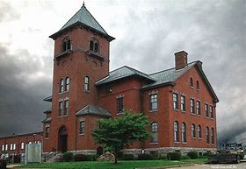

County Demographics

According to the most recent data provided by the US Census, Madison County is home to 12,626 residents. The current total population of Madison County has roughly increased 3.27% from 2010 to 2020. In fact, the county has seen a slow, but progressive rise in total population since 2000. The county is comprised of 4,633 households, with an average household size of 2.68. Looking at the demographic composition of Madison County’s population by age, we see that a majority of the population falls within the age range of 18 to 64 (roughly 7,222 individuals), 23.88% being under the age of 18 years, and 19.02% being older 65 years and older. English is the predominant language spoken amongst 97.2% of the County’s residents. The other languages that are spoken with the County include Spanish, which accounts for 2.2% of the population.

The current racial/ethnic distribution of residents in Madison County is predominantly made up of those who identify as White (91.99%), while the number of residents who self-identify as African American or Black is substantially lower at 0.44%. Other racial/ethnic present in Madison County are: American Indian or Alaska Native (0.50%); Asian (0.36%); Hispanic or Latino (2.71%); and with 5.58% of the population identifying as two or more races. Additionally, there is a small immigrant population with 235 or 1.86% of the Madison County population identifying “foreign born”. In addition to the racial/ethnic populations, there are 10.6% or 1,012 individuals in Madison County that are veterans.

Social Determinants of Health
The median per capita income in Madison County is $31,299. The income gap experienced in Madison County is roughly $5,500 when compared to the state of Missouri and nearly $10,000 when compared to the national per capita median income. The median household income is $54,042 which is nearly $12,000 less than the state and roughly $21,000 less than the national median total. When thinking about the income averages that are seen in Madison County, it draws into question what employment looks like. Based on the 2023 Census, the employment and labor force status in Madison County demonstrates that the employment rate was 52.9% compared to the Missouri rate of 61.5%. A majority of the workforce in Madison County (27.6%) work in the educational services, health care, and social assistance sectors. The following most popular employment sectors are manufacturing at 15.5%, retail trade at 12.2%, arts and entertainment at 7.6%, and construction at 7.2%. The remaining sectors that fall under 7% include transportation, warehousing, utilities, scientific, management, waste management, public administration, agriculture, forestry, fishing and hunting, mining, and all other non-public administration professions.
The 2023 census estimates that the poverty rate in the county is 14.0% which is higher than the state (12.0%). The poverty rates and household income also directly correlate to the childcare services that individuals and families are able to afford. On average, yearly costs for an infant center are $3,510 (roughly 6.5% of median income) and 4-year-old centers cost $3,380 (roughly 6.3% of median income) annually. Madison County is only home to 3 centers and 1 family childcare facility, which indicates that there is a lack of sufficient capacity for childcare age children. On the other hand, residents in Madison County have a higher rate of vehicle ownership at 2.2 cars per household, while the state rate is 1.9 and the national average is 1.8 cars per household.
Additionally, access to technology and high-speed internet (i.e. broadband and/or fiber optics) fares less favorably for Madison County residents with roughly 4,189 households having access. Roughly 88.45% of residents have consistent access to technology (e.g. smartphones, computers, cellphones) which is less than the state (93.02%) and national (93.95%) averages. When looking at education indicators, as of 2017, Madison County demonstrates a rate of 91.31% of residents have a high school diploma and 9.51% have some high school under their belt. However, the county ranks lower in those who have acquired a bachelor’s degree (16.1%), some college experience (28%), and those who have a graduate level degree (6%).

Health Behaviors

When looking at the health behaviors of the residents in Madison County, the rate for smokers is slightly higher than the state percentage (44.1%) with 45.1% of adults being habitual smokers. The opposite goes for excessive alcohol consumption with 21.3% of Madison County adults over the age of 21 partaking in excessive drinking compared to the state rate of 23.4%. There are also 32.9% of residents that utilize electronic cigarettes and 10.8% who have used some form of tobacco products within the last 30 days. Opioid use follows closely behind with overdose rates of 18.9%, overdose death rate at 16.2%, misuse ER visits coming in at 1.2%, and drug related arrests bringing up the rear at a whopping 261.4%. On the bright side, there is a 73.5% rate of individuals seeking substance use disorder treatment.

In 2021, there were 133 live births in Madison County. Additionally, when looking at reproductive health, there are significantly low rates of STIs with the most common STI being Chlamydia with a rate of 163.5 per 100,000 people. Gonorrhea is the next most prevalent STI with a rate of 16.4 per 100,000 people, with primary and secondary Syphilis coming in with no recorded cases in recent years.

Rounding out health behaviors, Madison County shows that 33.9% of the residents are obese, which is lower than the 35% across the state. Madison County also reports similar overweight residents (66.7%) to the state’s (66.9%) as well as a lack of physical activity which is experienced by 33.5% of residents in the County compared to 31.8% across the state. Disabilities can also play into obesity and a lack of physical activity, although Madison County only has 22.62% of residents that are disabled. These are the disabilities in descending order of prevalence beginning with cognitive disabilities at 7.9%, hearing disabilities at 7.5%, and vision disabilities at 4.8%. In addition, 4.1% struggle with self-care, 12.8% receive ambulatory care, and 9% are unable to live independently. Mental health also plays a large role in Madison County, with 26 suicides taking place in 2021 and depression affecting 24.1% of the residents. Residents also reported 5.6 out of every 30 days to be bad mental health days and roughly 20.47% reporting poor or fair mental health compared to the state’s 20.06%.

Morbidity & Mortality

Building on the health behaviors information, data illuminates the fact that 33.9% of residents have high cholesterol, 33.6% have hypertension, 11.4% have diabetes, 9.6% have Chronic obstructive pulmonary disease (COPD), 9.5% have asthma, and 4.3% have a history of a stroke. Altogether, Madison County reported roughly 1,045.38 deaths in 2021 with 98 per 100,000 being due to injuries and 7.14% relating to alcohol involved motor vehicle deaths.

However, the leading causes of the death within the county are heart disease with a rate of 241.49 and cancer with an incidence rate of 506.8 per 100,000 people. In total, there were 529.5 deaths related to cancer with lung and bronchus cancer, taking the lead with 110.6 of those deaths. The other prevalent types of cancer seen in Madison County are breast cancer with 100.6 deaths, prostate cancer with 97.4 deaths, colon and rectal cancer with 43.1 deaths, and melanoma with 26.3 deaths.

Overall, 26.19% of residents in Madison County reported poor or fair health compared to the 21.92% reporting the same across the state. Residents also reported that 4.4 out of every 30 days are poor health days.

Healthcare Access
Madison County is facing a shortage of not only physicians and dentists, but medical facilities. The County, not unlike others, has staggering ratios of primary care physicians to patients at 3,160:1 compared to Missouri’s ratio of 1,420:1. The same follows for dentists with a county ratio of 4,250:1 compared to the state’s 1,600:1. One surprising number is the mental health provider ratio of 510:1 which is not far from the state’s 410:1.
When looking at the available healthcare facilities in Madison County, there is one (1) hospital, two (2) skilled nursing facilities, thirteen (13) home health agencies, and one (1) mental health facility. Within the hospital there are five (5) different programs including: nursing home, outpatient clinic, urgent care, rural health clinic, and the physical therapy department. After understanding the difficulties with healthcare access, it is still important to mention that there are 15% or 1,856 people living in Madison County that are currently uninsured.

youth data
While most of the data pertains to adults, there is vital information that helps round out the picture of Madison County and that is the youth data. Based on the DMH 2022 Student Survey Results, the following results were collected:
30.6% of students reported the use of vapes, 19.4% reported alcohol use, and 12.6% reported various types of tobacco use. In addition, various types of drugs are being used as self-reported by the students of Madison County. The most common drugs are Marijuana at 14.5%, unprescribed prescription drugs at 4.9%, LSD/PCP/Mushrooms at 3.8%, over the counter drugs to get high at 2.5%, and other drugs that fall under 2% including meth and cocaine. These students also reported on their mental health with 16.6% seriously considered suicide, 12.1% planned suicide, and 7.4% attempted suicide. Additionally, there were 36% who had skipped school in the last 30 days, 8% did not attend school due to feeling unsafe, and 24.6% had been driven in a vehicle by someone who was drinking alcohol.
In addition to drug and alcohol use, crime rates among youth are very telling of a community’s story. Based on the DYS 2019 data, crime rates were the highest among 16-year-old males with 163 crimes committed and 16-year-old females with 32 crimes committed. A majority of all youth crimes committed for both males and females fell under the classification of C, D, E, and other felonies. To wrap up 2019, there were a total of 512 youth crimes committed in Madison County.

additional Data
There are a few data points that stand alone but are vital to understanding Madison County as a whole. First off is food insecurity, which impacts 15.3% of the community. 10.2% reported limited access to healthy food in 2023 and the County’s food environment index was rated 6.9 out of 10. There is also a substantial number of residents receiving benefits including SNAP (15.93%) and 51.5% of children are eligible for reduced lunches.
Housing is another sector of data that is important and has been a prominent issue within Madison County. There is a higher rate of homeowners in Madison County at 78.4% compared to Missouri’s 67.6%. As of 2022, there are an estimated 5,854 housing units within the county with 79% being occupied. When looking at the types and costs of housing in Madison County, 77% of the structures are single-family homes and fall around $127,300 which is less than the state median value of $199,400 and places Madison County in a position of being less expensive than 65% of the state.
Lastly is public transportation. While each household has roughly 2.2 vehicles, there is a lack of public transportation that is available, and many residents have an average travel time of 25.8 minutes to get to work. With only 1% of the population utilizing established public transportation. Southeast Missouri Transportation Service or SMTS is one of the main transportation companies serving Madison County, Monday through Friday. Each day they provide a different service path to surrounding counties and even offer long-distance services depending on the day. Additionally, SMTS provides reduced fare rates for individuals who are over 60 or who are under 60 with disability verification and these rates range from $3.00 to $36.00 based on the travel distance. The fares do not increase drastically for those who do not have a verified disability.

Community Context Assessment

CCA Summary
The Community Context Assessment (CCA) was conducted using the MAPP 2.0 framework to provide a primary source of data on community members’ views about their own health and the health of the community. By focusing on those with the greatest need, the CCA helps further prioritize the health issues that will be addressed by the CHIP. Before administering the CCA survey, a community meeting was held to identify relevant topics to include. After incorporating these topics into the survey, it was distributed to the community, generating 128 responses.
Overall, the respondent’s ranked Madison County a 3.61 (on a scale of 1-5, 1 being “not safe at all” and 5 being “extremely safe”) for safety with a majority giving the community a ranking of 4. They additionally indicated that safe and healthy homes, adequate employment, and quality education are the most important topics.
When asked about the most needed topics in health education, survey respondents identified mental/behavioral health and counseling as the top priority, followed by substance/opioid misuse and chronic diseases. Some other notable mentions are trauma awareness/response, nutrition, and vaping/e-cigarette use.
Questions regarding physical health revealed that a majority of survey respondents do not exercise once per week followed by a close second of those who do exercise 1-2 days per week. Additionally, respondents disclosed that they are consuming at least 1-2 servings or fruits and vegetables per day and know where they can access fresh fruits and vegetables in their community. Only a small percentage of respondents (3%) indicated that they are unsure of where to access fresh fruits and vegetables.
A majority of survey respondents answered that they annually receive a routine preventative health check-up. However, the responses demonstrate that respondents feel as if there is not equal access to healthcare in the community and that cost, appointment availability, and service availability are big factors in whether or not they receive healthcare. Additionally, there were mentions of vaccine safety concerns and personal beliefs holding parents back from vaccinating their children.
Understanding gained from the CCA will, with the CSA and CPA, guide the selection of health issues and health priorities to be addressed by the CHIP.

Process & Methods

The CCA began with a CHA kickoff meeting in which the community survey was discussed, and community meetings were scheduled. Next, the community survey was drafted using Microsoft Forms. The survey consisted of 40 questions and included multiple choice, rating scale, and open-answer questions. Then, the survey was reviewed in a community meeting, revised, and finalized.

Survey distribution was completed with the help of community partners who aided MCHD in delivering the survey to individuals and groups throughout the county. The survey was made available via physical copies, QR codes, and a website link, and was shared in face-to-face interactions, emails, and with physical QR codes being displayed or handed out at local organizations.

Survey results were analyzed through data visuals created by Microsoft Forms and compiled in Microsoft Excel. A data summary, also created by Microsoft Forms, was compiled, printed, and distributed to community partners at a follow-up community meeting where the data was analyzed and discussed.

Survey Demographics
There were a total of 128 respondents that participated in the Madison County community health survey. The survey breaks down the responses by the 7 zip codes within the county, however, only three zip codes had survey participants. Most of the responses (116) were from 63645, with 11 coming from 63655 and 1 from 63636.
The survey responses were comprised of mostly White respondents (125), 1 Hispanic or Latino respondent, and 1 respondent who is two or more races. The responses for race and age align well with the data pulled for the Community Status Assessment and therefore do not come as a surprise. The CSA data demonstrated that Madison County is a fairly middle-aged county with most community members falling between the ages of 18-65 and the survey results are not different. The most common age range to complete the survey was 3645 with 39 responses, 46-55 with 36 responses, and 26-35 with 25 responses. It was also interesting to see that a majority of responses were complete by women (84%) since Madison County is split fairly evenly when it comes to gender identity.
Another interesting demographic is educational attainment. The survey question asked what the highest level of education attained is and 64 respondents indicated having either a bachelor’s (40) or master’s (24) degree. This information varies from the CSA data was pulled as it indicates a higher level of high school graduation.

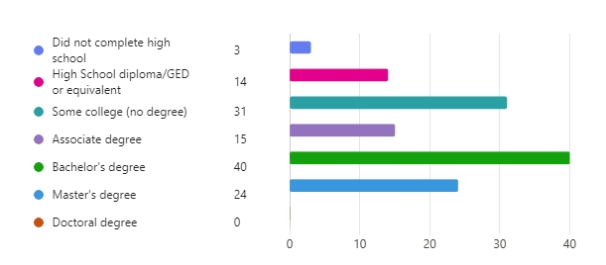

Quality of Life
The survey responses indicate that the top 3 most important topics to those living in Madison County are safe and healthy homes, adequate employment, and quality education.
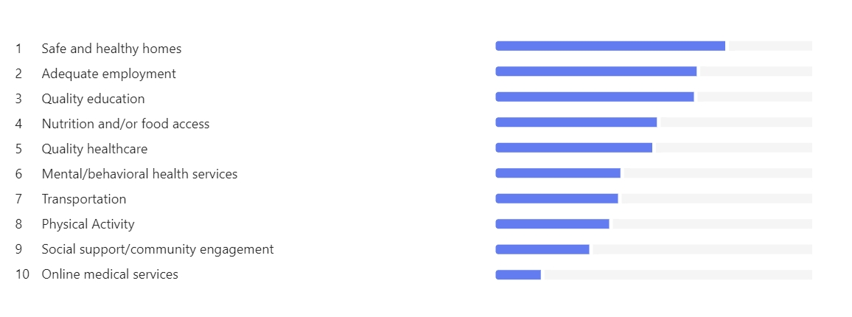

Nutrition/food access and quality healthcare follow close behind the top three, which is logical given that the data from the survey indicates that community members would like more access to fresh fruits and vegetables and would like a wider variety of healthcare services and appointment availability.
Additional questions about transportation were added to the survey as data surrounding this topic was lacking. The questions were aimed at assessing the need for public transportation as well as the likelihood of public transportation being used within the community. The responses demonstrate that the community believes there is a need for public transportation with 106 voting “Yes”, 4 voting “No”, and 17 voting “unsure”.

Healthcare
When asking respondents if they are satisfied with the healthcare services that are available in their community, these were the responses given:
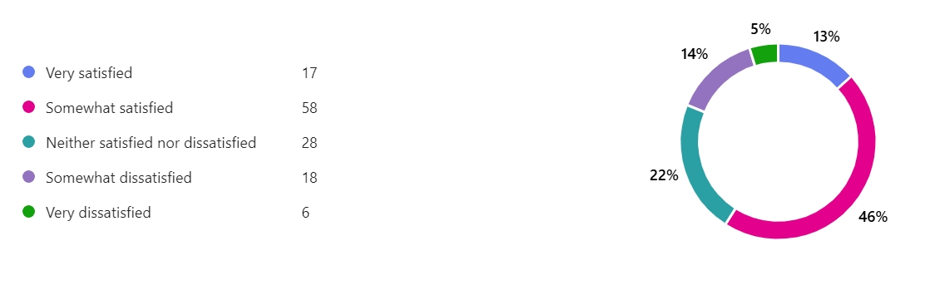
This also correlates to the responses indicating that there are inequalities when it comes to accessing healthcare services. Additionally, respondents specified that the cost, appointment availability, and service availability are the three biggest barriers to accessing health services. Other barriers include lack of information, transportation, and cultural or linguistic barriers. 35% of respondents answered that cost was such a significant barrier that they had to go without healthcare due to the cost of it. It is also important to note that 80% of respondents indicated that they have annual health checkups and 10% receive one every 2-3 years. Lastly, there were varied responses when it comes to the travel distance to get to a family doctor. 31% of respondents fall within the 0–5 mile radius, 28% fall within the 11-20 mile radius, and 23% fall within the 6-10 miles radius. There were 23 respondents who travel anywhere from 21 to 31+ miles to reach their family doctor.

Physical & Mental Health
When questioned on how they would rate their physical health, 52 respondents stated average, 47 stated somewhat good, and 17 stated excellent. This leaves 12 individuals rating their physical health somewhat poor (10) and poor (2). Respondents were then questioned about exercise habits as well as the accessibility to exercise spaces. The responses demonstrated that 62% of respondents have accessible exercise space near them. In opposition, 34% indicated that they do not have nearby space and 4% are unsure. In total, 95 respondents answered that they exercise between 0-1 days per week (50) and 1-2 days per week (45). There are the select few, 32 respondents, that are exercising 3-7 days per week.
While gaining information on physical health, mental health was also an interest area for this survey. The results are fairly similar to that of physical health with 112 respondents falling with the ranges of excellent (30), somewhat good (40), and average (42). However, there were more responses for somewhat poor (11), poor (4), and unsure (1) than what was witnessed for physical health. To compliment this data, a question was asked regarding know-how on accessing mental health services and 84% of respondents know where to access these services should they need them.

Health Education
Health education is vital to a well-rounded community and when questioned about medical/public health information sources, the survey participants selected these top three sources for their information: doctor/physician, internet/social media, and family and friends. These participants were also asked what topics they were most interested in receiving education on and the top three answers are: mental/behavioral health and counseling, substance/opioid misuse, and chronic diseases (heart disease, stroke, COPD, diabetes, etc.). The following education requests are as follows: 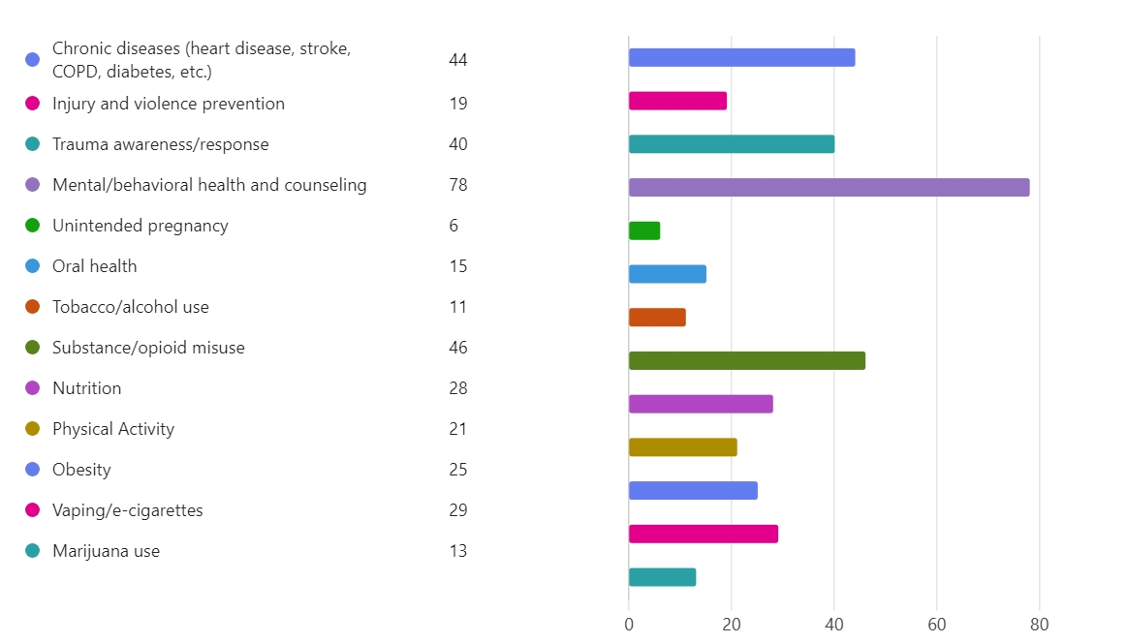

Substance Use
Substance use is a major area of concern within the community not only for adults but for the youth as well. The top three substances in Madison County, as indicated by the results of the survey, are alcohol, e-cigarettes/vaping, and opioids. Opioid misuse was also included in the survey as a scale question to gauge the prevalence with 1 being “not prevalent” and 5 being “extremely prevalent” and it was rated a 4.10 indicating a high prevalence of opioid misuse in the county. The survey also collected information on alcohol and electronic smoking use among the under 21 demographic. The results show that many respondents agree that there is frequent to very frequent alcohol and e-cigarette use among those under 21. It was also demonstrated in the survey that respondents agree or strongly agree that those under 21 are causing harm to themselves or others by consuming alcohol and using e-cigarettes.

Looking Forward
The CCA was invaluable in discovering how Madison County residents view health in their community and which improved health outcomes are most valued. The unique real-world experiences of those living in Madison County offer insights into the quality of life in the county and what will be required to create positive change.
While survey results may not reflect the perspectives of the entire Madison County population, responses originate from the most populated zip codes in the county and represent many different age groups, providing a useful representation of the attitudes of many Madison County residents. In tandem with one another, the CSA and CCA results summarize data about the county necessary to select priorities for the CHIP that will lead to the best health outcomes for Madison County.

Community Partner Assessment
The Community Partner Assessment (CPA) is a MAPP tool used by community partners to assess their ability to address health inequities. The CPA has five main goals:




Describe why community partnerships are critical to community health improvement (CHI) and how to build or strengthen relationships with community partners and organizations.
Name the specific roles of each community partner to support the local public health system (LPHS) and engage communities experiencing inequities produced by systems.
Assess each MAPP partner’s capacities, skills, and strengths to improve community health, health equity, and advance MAPP goals.

Document the landscape of MAPP community partners, including grassroots and community power-building organizations, to summarize collective strengths and opportunities for improvement.
Identify whom else to involve in MAPP and ways to improve community partnerships, engagement, and power-building.

CPA Meeting Overview and health equity
MCHD held a meeting with community partners to capture their thoughts about the resources they can contribute to community health improvement. The meeting began with a discussion about health equity and how it differs from health equality as well as its significance to the MAPP framework and CHA process.
Additionally, community partners discussed social determinants of health, which are the physical and social conditions that can impact an individual’s health outcomes and quality of life. The discussion branched to the community partners discussing how their organizations contribute to addressing these SDOH. These conversations about health equity and SDOH were referred to often in subsequent meetings, guiding the CHA process.

Organizational Activities & the Essential Public Health Services (or SDOH)
In the CPA meeting, community partners brainstormed and had a long open-ended discussion regarding what activities each of their organizations participates in and how these activities are being implemented in ways that meet the criteria for all the SDOH categories. This conversation included note taking, networking, and current or reoccurring problem discussion that allowed other community partners to fill gaps and access new resources.

Conversation pieces

CPA Survey
Overview:
This survey included 30 questions, took roughly 6.5 minutes for completion on average, and was completed by 13 community partners that attended the meeting. The survey asked a wide array of questions to be able to gauge the services, interest, what type of organizations, how they collect data, and how they have interacted with the community.

Interests and Services:
These were the results of the interests and services that could be provided by community members:
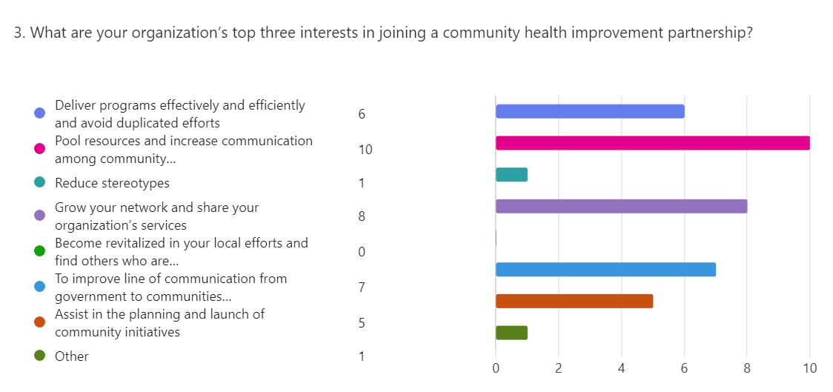

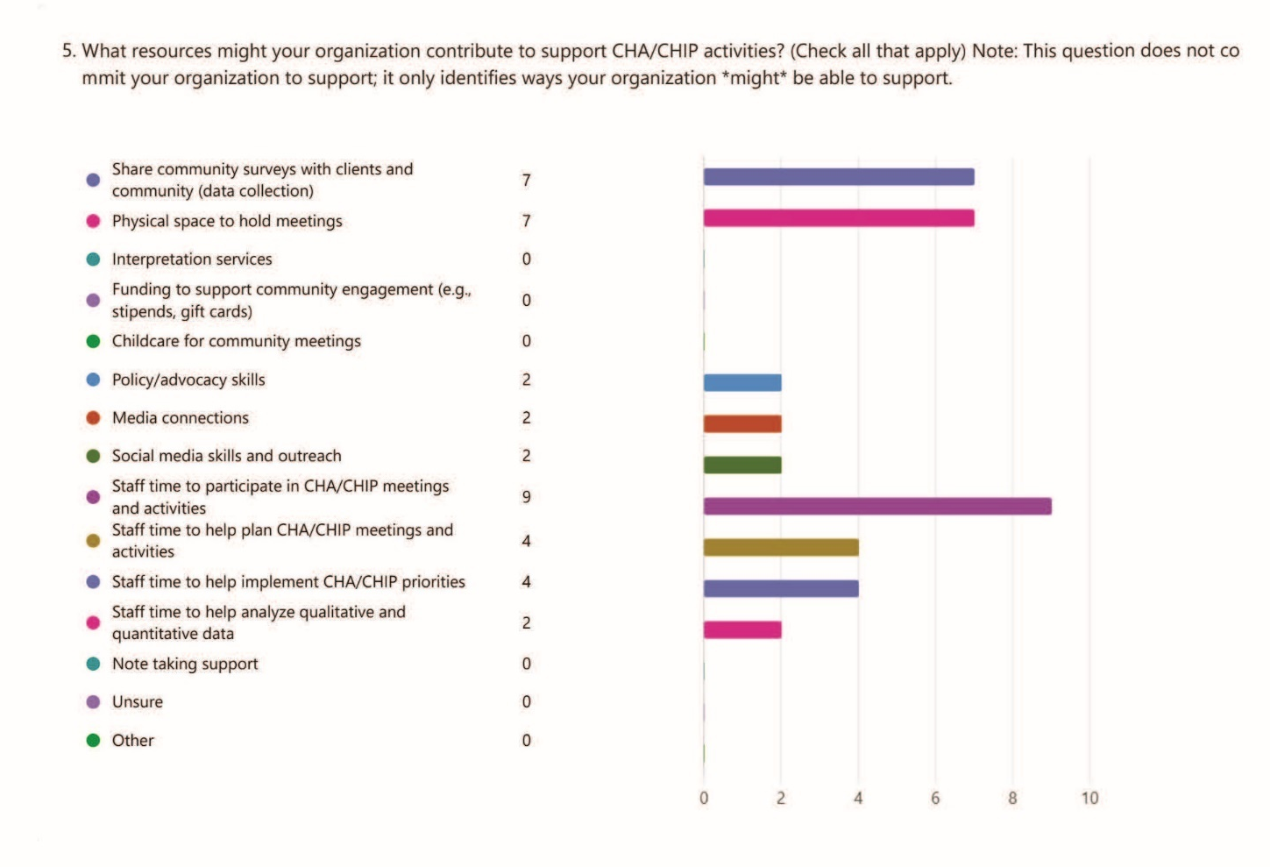
Focus Areas:
Building on their discussions about health equity, organizational activities, and SDOH, as well as their unique experiences within the community, partners identified their top four health priorities to be addressed by CHIP. The results, once categorized, revealed that the following four overarching health topics were the most commonly agreed upon priorities:
- Mental Health
- Substance Use Prevention
- Health Education
- Chronic Disease Awareness
Data Collection & Analysis:
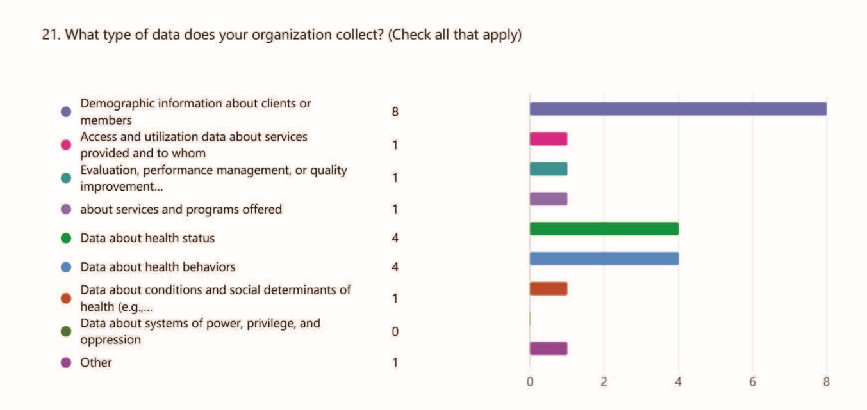
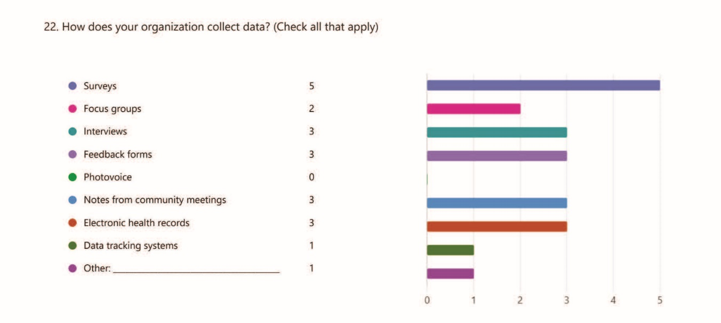

Community Engagement and Communications:
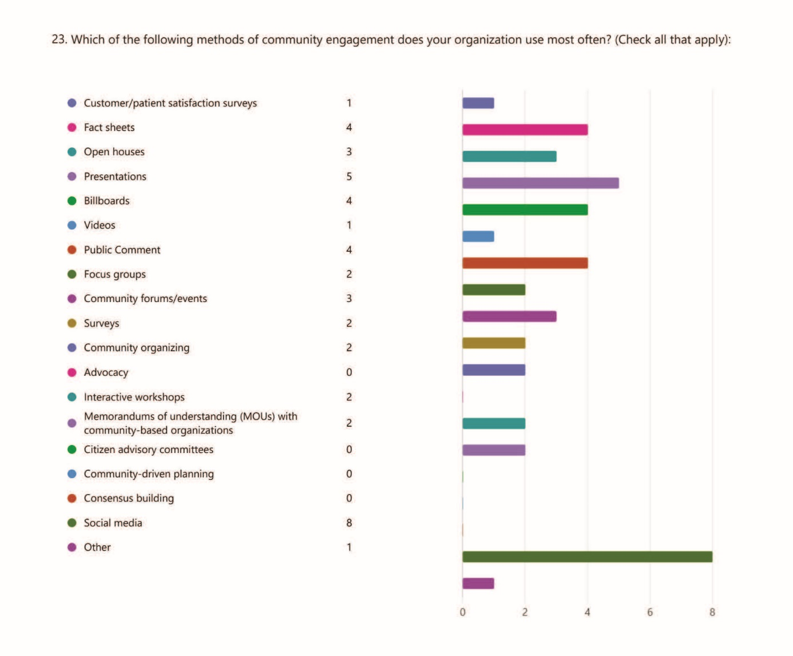

CPA Reflection
From the CPA meeting, MCHD learned that community partners are poised to improve access to care by increasing communication among groups and delivering programs more effectively and efficiently. Although some partners have not previously participated in a CHI process, each has already been engaging in activities that support CHI goals. By recognizing strengths and gaps, MCHD and partners can better allocate time and resources to MAPP activities that address Madison County’s most critical health challenges, establishing a sustainable CHI process for years to come.

CHA Next Steps
To conduct the Community Health Assessment (CHA), MCHD and community partners successfully completed a Community Status Assessment (CSA), Community Context Assessment (CCA), and Community Partner Assessment (CPA). These three assessments have provided a comprehensive view of the health of Madison County by offering data on the county’s current health status, residents’ perceptions about health topics and areas for improvement, and the resources available through community partners. Without the CHA, prioritizing health issues based on the needs of county residents would not be possible. Through the CHA process, the Madison County community has come together in a rewarding collaboration, establishing a strong foundation for progressing Community Health Improvement (CHI).
Since the completion of the CHA, the following health priorities have been identified by MCHD and our partners and will guide our county’s Community Health Improvement Plan (CHIP):
- Mental Health
- Substance Use Prevention
- Health Education
- Chronic Disease Awareness
Moving forward, CHA results will be disseminated throughout the community, highlighting key health issues and encouraging collaboration. MCHD and partners will continue working together to address the identified health priorities by setting goals and developing effective interventions as they create and implement a CHIP for Madison County.

Sources
PolicyMap - Dig Deeper - All Other Information Not Listed Below
missouri-student-survey-2024-madison-county.pdf (mo.gov) - Youth Smoking
Missouri Broadband Map (mo.gov) - Internet Data
Query Builder (mo.gov) - Preventable Hospitalizations
- MCDS (mo.gov) - Free and Reduced lunches
Query Builder (mo.gov) - Birth Rates
Madison, Missouri | County Health Rankings & Roadmaps - Provider ratios
https://censusreporter.org/profiles/05000US29123-madison-county-mo/#:~:text=Occupied79%25-,Occupied,Single%20unit77%25 - Housing and Other
https://www.rentdata.org/madison-county-mo/2021#google_vignette - Fair Market Housing
https://mochildcareaware.org/data-and-reports/mo-county-supply-reports/ - Childcare
https://dmh.mo.gov/alcohol-drug/mobhew/missouri-student-survey-reports/2022 - Youth Data
https://dss.mo.gov/re/pdf/dys/youth-services-annual-report-fy19.pdf - Youth Crime
Madison County, Missouri - Census Bureau Profile - Poverty Rates Data 2023
Madison County, Missouri - Census Bureau Profile - Employment Rates Data 2023

